**LIC AAO Prelims 2019 (Solutions)**

**REASONING ABILITY**

**Solutions (1-5):**

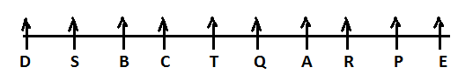

**1. (c); 2. (c); 3. (d);**

**4. (c); 5. (b);**

**Solutions (6-8):**

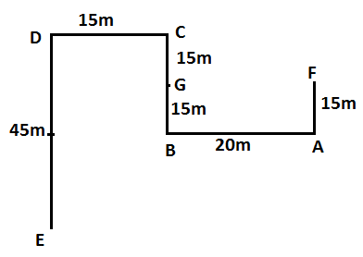

**6. (c); 7. (d); 8. (d);**

**9. (d); I.** A $>$ L (False) **II.** B $≥$ K (False)

**10. (b); I.** A $≥$ B (False) **II.** B $<$ K (True)

**11. (e); I.** N $>$ P (True) **II.** K $≤$ N (True)

**12. (c); I.** V $≥$ S (False) **II.** S $>$ V (False)

**13. (b); I.** K $>$ A (False) **II.** A $≤$ K (True)

**Solutions (14-18):**

|  |  |  |
| --- | --- | --- |
| **Months** | **15th** | **28th** |
| **January (31)** | Q (Chemistry) | S (Geography) |
| **April (30)** | U (Economics) | T (Physics) |
| **July (31)** | R (Biology) | P (History) |

**14. (b); 15. (a); 16. (d);**

**17. (e); 18. (e);**

**19. (e);**

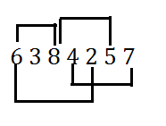

**20. (d);** ‘**FBD’**

**Solutions (21-25):**

|  |
| --- |
| **Persons** |
| S |
| W |
| R |
| P |
| Q |
| T |
| V |

**21. (c); 22. (b); 23. (a);**

**24. (c); 25. (d);**

**26. (a);**

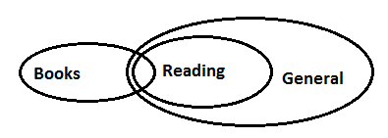

**27. (d);**

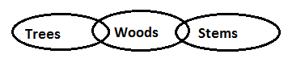

**28. (c);**

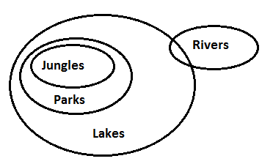

**29. (e);**

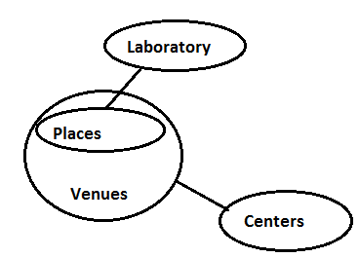

**30. (d);**

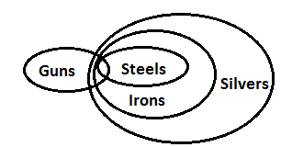

**Solutions (31-35):**

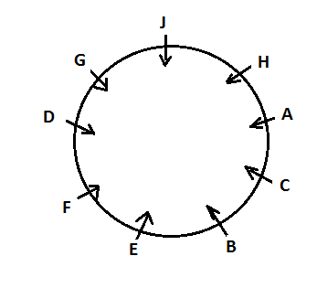

**31. (b); 32. (d); 33. (a);**

**34. (e); 35. (d);**

**QUANTITATIVE APTITUDE**

**36. (b);**

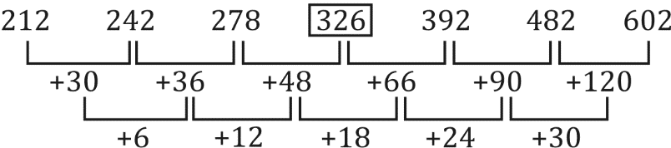

So, there must be 326 instead of 324.

**37. (e);** 12 × 1 + 1 = 13

13 × 2 + 2 = 28

28 × 3 + 3 = 87

87 × 4 + 4 = $\boxed{ 352}$

352 × 5 + 5 = 1765

1765 × 6 + 6 = 10596

So, there must be 352 instead of 351

**38. (a);**



So, there must be 1260 instead of 1263.

**39. (d);**  9 × 2 = 18

18 × 4 = $\boxed{ 72}$

72 × 6 = 432

432 × 8 = 3456

3456 × 10 = 34560

34560 × 12 = 414720

So, there must be 72 instead of 76.

**40. (b);** 12 + 18 = 30

30 + 18 = 48

48 + 30 = $\boxed{78}$

78 + 48 = 126

126 + 78 = 204

So, there must be 78 instead of 72.

**41. (c);** no. of people who visited on Wednesday

= $1200×\frac{20}{100}=240$

Required percentage = $\frac{240-96}{240}×100=60\%$

**42. (a);** no. of male visited on Monday

= $1200×\frac{30}{100}-144=216$

Required ratio = $216:128$ = $27:16$

**43. (b);** total no. of female who visited park = $144+314+96+128=682$

Total no. of males who visited park = $1200-682=518$

Required difference = $682-518=164$

**44. (d);** total no. of male visited on Wednesday

= $1200×\frac{20}{100}-96=144$

Total no. of people who visited on Monday

= $1200×\frac{30}{100}=360$

Required percentage = $\frac{144}{360}×100=40\%$

**45. (e);** no. of male who visited on Tuesday = $1200×\frac{35}{100}-314=106$

No. of male who visited on Friday = $\frac{25}{100}\left[1200×\frac{30}{100}-144\right]=54$

Required ratio = $106:54$ = 53:27

**46. (c);** Let time taken be T sec.

So, T $=\frac{200}{\left(25-5\right)}=\frac{200}{20}=10 sec$

**47. (c);** Total no. of possible outcomes = 36

Possibility of getting sum of 6 = 5 i.e. [ (1,5), (2,4), (3,3), (4,2), (5,1)]

So, required possibility $=\frac{5}{36}$

**48. (d);** Let B invested Rs x.

Ratio of profit share of A and B $=\frac{12000 × 12}{x × 5}=\frac{1}{1}$

x = Rs. 28800

**49. (e);** Quantity of alcohol in the initial mixture= 1 – 0.3 = 0.7 lit

Let x lit of alcohol is added in the mixture.

ATQ

$\frac{0.7+x}{0.3}=\frac{85}{15}$

$x=1 lit$

**50. (e);** Let the total capacity of the cistern be 60 units (LCM)

So, the efficiency of pipe A = 4 units/hr

The efficiency of pipe B = 5 units/hr

So, the time taken by pipe A and B together $and due to leakage =\frac{60}{9}+\frac{20}{60}=7 hours$

Let efficiency of leakage is x units/hr

ATQ

$7\left(5+4-x\right)=60$

$x=\frac{3}{7}\frac{units}{hr}$

Required time = $\frac{60}{3}×7=140 hr$

**51. (e);** Let the age of the father and son is 8x and x respectively.

So, the age of the mother is 7x.

ATQ

$8x=7x+6$

$x=6$

So, the age of the father $=8x=48$

**52. (b);** Laptops sold by company-B & C together in May = 1000 + 800 = 1800

Laptops sold by company-D in April = 1200

Required % = $\frac{1800 – 1200}{1200}$ × 100

$=\frac{600}{1200}×100$ = 50%

**53. (d);** Laptops sold by company-A & B together in April = 800 + 400 = 1200

Average number of laptops sold by company-C & E in May

= $\left(\frac{800 + 1200}{2}\right)$ = 1000

Required difference = 1200 – 1000 = 200

**54. (b);** Laptops sold by company-B & E together in April = 400 + 600 = 1000

Laptops sold by company-C & D together in May = 800 + 960 = 1760

Required ratio = $\frac{1000}{1760}$ = 25 : 44

**55. (a);** Average number of laptops sold by company-A, D & E in May = $\frac{1200 + 960 + 1200}{3}$ = 1120

Required % = $\frac{1120}{1000}$ × 100 = 112%

**56. (e);** Total laptops sold by all 5 companies in May = 1200 + 1000 + 800 + 960 + 1200 = 5160

Total laptops sold by all 5 companies in April = 800 + 400 + 1000 + 1200 + 600 = 4000

Required % = $\frac{5160 – 4000}{4000}×100$

$=\frac{1160}{40}\%$ = 29%

**57. (c);** Laptop sold by company-A & E together in April = 800 + 600 = 1400

Laptop sold by company-B & D together in May = 1000 + 960 = 1960

Required ratio = $\frac{1400}{1960}$ = $\frac{5}{7}$ = 5 : 7

**58. (a);** Let the cost price of first product and second product be Rs x and Rs y respectively.

So, x + y = 4400 ……(i)

$x+y=\frac{115}{100}x+\frac{82}{100}y ……\left(ii\right)$

From (i) and (ii)

$\frac{x}{y}=\frac{6}{5}$

Let x = 6a and y = 5a

So, 11a = 4400

$a=400$

So, x = 2400

**59. (a);** Let monthly salary $=Rs 100x$

ATQ

$100x×\frac{90}{100}×\frac{70}{100}=63x$

Let total expense on medicine and groceries $=3y+4y=7y$

So, $7y=63x$

$y=9x$

Given, 3y = 8100,

So, y = 2700

Now, $x=300$

$∴$ monthly salary of the man

$=100x=Rs 30,000$

**60. (b);** Let r be the radius of the sphere.

Given, $4πr^{2}=616$

$r=7 cm$

So, side of the square = 7 cm

Now, perimeter of the square $=4×7=28 cm$

**61. (b);** Upstream speed of first boat = 8 km/h

Upstream speed of second boat = 4 km/h

Relative speed = 4 km/h

Required time = 10/4= 2.5 hours

**62. (d);** Let length and breadth of the rectangle be l cm and b cm and side of the square be a cm.

ATQ

$l×b=4a^{2}$

$60×a=4a^{2}$

$a=15 cm$

**63. (b);** Let A and B can do $3x$ and $4x$ unit of work in one day.

So,

Total work = $\left(3x+4x\right)×8=56x$

(A + B) two day work = $7x×2=14x$

Remaining work = 42 $x$

In 6 days B will complete = 6 × 4 $x$ = 24 $x$ units

So, remaining 18 $x$ units are completed by C in 6 day

So,

$56x unit will be completed in =\frac{56x}{\frac{18x}{6}}=\frac{56}{3} days$

**64. (d);** Profit will be shared in ratio

$= 4 × 6 : 8×3 : 9×4$ $=2 :2 :3$

$C’s profit=\frac{16750}{2}×3=25125$

**65. (b); $9×49=\frac{72}{?}-\frac{9}{?}$**

$?=\frac{1}{7}$

**66. (c);** 110 × $\frac{420}{70}+500-40= ?×\frac{5600}{100}$

660 + 460 = 56 $×$?

? = $\frac{1120}{56}$

? = 20

**67. (b); $60\% of 1540+\frac{37.5}{100}×96+1≈{\left(?\right)}^{2}$**

$⇒924+\frac{3}{8}×96+1={\left(?\right)}^{2}$

$$⇒{\left(?\right)}^{2}=924+36+1$$

⇒ (?)² = 961

⇒ ? = 31

**68. (e);** ?3

Or ?

**69. (c);**

**70. (a); $\frac{70}{100}×\frac{445}{14}=\frac{436}{?}$**

$?=\frac{436}{70×445}×14×100$

$?≃20$

**ENGLISH LANGUAGE**

**71. (b);** The answer to the question can be inferred from the paragraph second and fourth of the passage, ‘…. Customers expect to be able to interact with companies through modern technology…’ and ‘….which typically includes invasive questions and surveys about to dictate premiums…’ Also there is no mention of the busy schedule of the customers in the passage. Hence, option (b); is the correct answer.

**72. (e);** The answer to the question can be inferred from first and second paragraph of the passage, ‘…AI can be applied to improve the claims process…’ and ‘…AI-powered claims could also fight against one of the most costly elements of the insurance industry fraudulent claims…’, ‘….a recent survey found that 74% of consumers say they would be happy to get computer-generated insurance advice….’ Hence, option (e); is the correct answer.

**73. (a);** The answer to this question can be inferred from the paragraph four of the passage, ‘…In the insurance space, chatbots can be used to answer basic questions and resolve claims, as well as sell products, address leads, or make sure customers are properly covered…..’ Hence, option (a); is the correct answer.

**74. (b);** The answer to this question can be inferred from the first paragraph of the passage, ‘…new process of “touch less” claims is introduced in the industry. This process uses artificial intelligence and other technology to report the claim, capture damage, audit the system, and communicate with the customer…’ Hence, option (b); is the correct answer.

**75. (d);**  Invasive means invading or tending to invade.

Meager means irrelevant or insignificant.

Strenuous means requiring great effort.

Peculiar means particular or special.

Nosy means showing too much curiosity in people’s affairs.

Although option (a); appears to be the correct alternative but it is not similar to the sense in which the word ‘Invasive’ is used in the passage. Hence, option(d); is the correct answer.

**76. (a);** Notorious means infamous

Disreputable means having a bad reputation.

Indecent means not appropriating or fitting.

Abjure means to renounce or give up.

Sluggish means lacking energy or alertness.

So from the given options, only option (a); is the correct synonym of the word ‘Notorious’. Hence, option (a); is the correct answer.

**77. (c);** Antiquated means old, outdated

From the given options, options (a); , (b); and (d); are synonyms of the word Antiquated. Hence, option (c); is the correct answer.

**78. (b);** A ‘Mantle’ is a shawl or cloak whereas ‘Mantel’ is the shelf or slab. So in option (a); , (c); and (d); the correct word should be ‘Mantel’. Hence, option (b); is the correct answer.

**79. (d);** ‘Feat’ is defined as something that require great courage and skill to achieve whereas ‘Feet’ is lower extremity of the leg below the ankle, on which a person stands. Hence, option (d); is the correct answer.

**80. (a);** ‘Flair’ means a special aptitude or ability for doing something right whereas ‘Flare’ means a sudden burst of bright flame or light. Also the use of ‘flairs’ is grammatically incorrect instead it should be ‘flare’. Hence, option (a); is the correct answer.

**81. (c);** Ranging means extended between specified limits.

Excluding means not taking something into account.

Covering means including all the possible options.

Governing means having authority to conduct the policy.

So from the given options, only option (c); makes the sentence contextually and grammatically correct. Hence, option (c); is the correct answer.

**82. (b);** Service means to perform routine maintenance work

Aiding means to help or support something.

Yearning means feeling of intense longing.

Abiding means lasting a long time.

So from the given options, only option (b); makes the sentence contextually and grammatically correct. Hence, option (b); is the correct answer.

**83. (d);** Amplified means to increase in magnitude.

Aided means to help or support something.

Rectified means to put right or correct.

Indemnify means compensate for harm or loss. Although option (b); and (d); makes the sentence contextually correct but option (b); is not grammatically correct. Hence, option (d); is the correct answer.

**84. (a);** Disablement means condition of being unable to perform.

Functionality means the quality of being able to serve a purpose.

Reimbursement means a sum paid to cover money that has been spent

Enigma means a person or thing that is difficult to understand.

So from the given options, only option (a); makes the sentence contextually correct. Hence, option (a); is the correct answer.

**85. (c);** Miniscule means extremely small.

Superficial means appearing to be true until examined.

Humongous means huge or enormous.

So from the given options, only option (c); makes the sentence contextually correct. Hence, option (c); is the correct answer.

**86. (b);** In the second part of the sentence, the word “were” will be replaced by the word “was” because when two subjects are combined with ‘together with’, the main subject is the one which is written before together with, and the verb follows the main subject. Apart from the grammatical error word “fataly” is incorrectly spelt.

Fatally- with death as a result.

Hence, option (b); will be the correct answer.

**87. (b);** In the second part of the sentence, the word “lived” will be replaced by “has lived” or “has been living” because “is watching” used in first part of the sentence and “has never created” used in the third part of the sentence signify that the sentence is in present tense. Both the given bold words are correctly spelt. Hence, option (b); will be the correct answer.

**88. (d);** In the fourth part of the sentence, “are” should be replaced by “is” because the subject of the statement starts with “Each of” and such sentences always follow singular Verb. Apart from the grammatical error word “Hal” is incorrectly spelt.

“Hall” is the correctly spelt word. Hence, option (d); will be the correct answer.

**89. (c);** In the third part of the sentence, “when” will be replaced by “than” because ‘No sooner’ is always followed by ‘than’ and ‘Hardly/Scarcely’ is followed by ‘when/before’.

Apart from the grammatical error word “Hal” is incorrectly spelt.

“Electrecity” is the incorrectly spelt word. Hence, option (c); will be the correct answer.

**90. (d);** In the fourth part of the sentence, “cares” should be replaced by “care” because if two subjects are combined using ‘Either…or’ or ‘Neither…nor’ then the verb always follows the subject near to it, which in this case is ‘the city corporations’. So the verb will be plural. Both the given bold words are correctly spelt. Hence, option (d); will be the correct answer.

**91. (a);** As provided in the question, statement (e); is the first statement of the paragraph in which there is a mention of the prerequisite for the youths to become good citizens in future. Sentence (e); and (F) forms a coherent pair as sentence (F) has talked that youths need to learn the skills to get themselves into the job and thus contributing to the country’s economy. Sentence (c); is consecutively following sentence (F) as it has mentioned the other things that youths should follow to know their country more. Moreover, sentence (d); and (a); are forming a contextually logical pair, the clue can be inferred from the joining word “success.” Sentence (d); is talking about the entire nation’s success and sentence (a); is talking about how to achieve that success on continuous pace. Thus, **sentence (a);** becomes the last sentence of the paragraph as it describes about the role of government in order to provide the facilities to the youth to achieve that success. However, sentence (b); fails to connect with the theme of the paragraph as it is describing about the focus on laws, policies and legal frameworks by banks which will help the young generation to utilize their full potential. Therefore, with the elimination of sentence (b); the sequence thus formed is **EFCDA.** Hence, **option (a);** becomes the most suitable answer choice.

**92. (d);** As provided in the question, statement (e); is the first statement of the paragraph in which there is a mention of the prerequisite for the youths to become good citizens in future. Sentence (e); and (F) forms a coherent pair as sentence (F) has talked that youths need to learn the skills to get themselves into the job and thus contributing to the country’s economy. Sentence (c); is consecutively following sentence (F) as it has mentioned the other things that youths should follow to know their country more. Moreover, sentence (d); and (a); are forming a contextually logical pair, the clue can be inferred from the joining word “success.” Sentence (d); is talking about the entire nation’s success and sentence (a); is talking about how to achieve that success on continuous pace. Thus, **sentence (a);** becomes the last sentence of the paragraph as it describes about the role of government in order to provide the facilities to the youth to achieve that success. However, sentence (b); fails to connect with the theme of the paragraph as it is describing about the focus on laws, policies and legal frameworks by banks which will help the young generation to utilize their full potential. Therefore, with the elimination of sentence (b); the sequence thus formed is **EFCDA.** Therefore, only **option (d);** i.e., **statement (b);** does not follow the theme of the paragraph as it is describing about the import duties levied by India in various sectors.

**93. (c);** Statement (e); is the first statement of the paragraph in which there is a mention of the prerequisite for the youths to become good citizens in future. Sentence (e); and (F) forms a coherent pair as sentence (F) has talked that youths need to learn the skills to get themselves into the job and thus contributing to the country’s economy. Sentence (c); is consecutively following sentence (F) as it has mentioned the other things that youths should follow to know their country more. Moreover, sentence (d); and (a); are forming a contextually logical pair, the clue can be inferred from the joining word “success.” Sentence (d); is talking about the entire nation’s success and sentence (a); is talking about how to achieve that success on continuous pace. Thus, **sentence (a);** becomes the last sentence of the paragraph as it describes about the role of government in order to provide the facilities to the youth to achieve that success. However, sentence (b); fails to connect with the theme of the paragraph as it is describing about the focus on laws, policies and legal frameworks by banks which will help the young generation to utilize their full potential. Therefore, with the elimination of sentence (b); the sequence thus formed is **EFCDA.** Thus, **option (c);** is the correct answer choice.

**94. (d);** Statement (e); is the first statement of the paragraph in which there is a mention of the prerequisite for the youths to become good citizens in future. Sentence (e); and (F) forms a coherent pair as sentence (F) has talked that youths need to learn the skills to get themselves into the job and thus contributing to the country’s economy. Sentence (c); is consecutively following sentence (F) as it has mentioned the other things that youths should follow to know their country more. Moreover, sentence (d); and (a); are forming a contextually logical pair, the clue can be inferred from the joining word “success.” Sentence (d); is talking about the entire nation’s success and sentence (a); is talking about how to achieve that success on continuous pace. Thus, **sentence (a);** becomes the last sentence of the paragraph as it describes about the role of government in order to provide the facilities to the youth to achieve that success. However, sentence (b); fails to connect with the theme of the paragraph as it is describing about the focus on laws, policies and legal frameworks by banks which will help the young generation to utilize their full potential. Therefore, with the elimination of sentence (b); the sequence thus formed is **EFCDA.** Therefore, **option (d);** is the correct choice.

**95. (d);** As provided in the question, statement (e); is the first statement of the paragraph in which there is a mention of the prerequisite for the youths to become good citizens in future. Sentence (e); and (F) forms a coherent pair as sentence (F) has talked that youths need to learn the skills to get themselves into the job and thus contributing to the country’s economy. Sentence (c); is consecutively following sentence (F) as it has mentioned the other things that youths should follow to know their country more. Moreover, sentence (d); and (a); are forming a contextually logical pair, the clue can be inferred from the joining word “success.” Sentence (d); is talking about the entire nation’s success and sentence (a); is talking about how to achieve that success on continuous pace. Thus, **sentence (a);** becomes the last sentence of the paragraph as it describes about the role of government in order to provide the facilities to the youth to achieve that success. However, sentence (b); fails to connect with the theme of the paragraph as it is describing about the focus on laws, policies and legal frameworks by banks which will help the young generation to utilize their full potential. Therefore, with the elimination of sentence (b); the sequence thus formed is **EFCDA.** Hence, **option (d);** becomes the most suitable answer choice.

**96. (c);** Sentence (III) is incorrect as the subject of the sentence ‘information’ is uncountable noun and is singular. Hence ‘was’ will be used in place of ‘were’.

Sentence (IV) contains an error of subject-verb agreement. Some nouns ending in ‘s’[eg: statistics] appear to be plural , but generally refer to only one thing and are, therefore, generally considered singular.

Here, only (I)& (II) statements are grammatically and contextually meaningful. Hence, option (c); is the most suitable answer choice.

**97. (a);** Sentence (II) is incorrect. ‘that’ is the correct use instead of ‘what’ as ‘that’ is used in the form of relative pronoun after ‘nothing, anything’.

Sentence (III) is incorrect. ‘on’ will be used after ‘later’ as ‘later’ means ‘afterwards’ whereas ‘later on’ means ‘in the future, or after the time already mentioned’.

Among the given sentences, statement (IV) contains a grammatical error. It is to be noted When plural nouns do not end in s, the possessiveness of it can be denoted by simply adding apostrophe and an ‘s’ [‘s] after the noun; however, if the plural noun already ends in s, a mere addition of an apostrophe signifies its possessiveness. Therefore, teacher’s should be replaced by teachers’.

Here, only the statement given in (I) is correct. Hence, option (a); is the most suitable answer choice.

**98. (e);**  All the given sentences are grammatically correct.

**99. (b);**  Sentence (I) is incorrect. ‘whom’ will be used in place of ‘who’ as ‘who’ is a nominative case after which a verb is necessary while ‘whom’ is an objective case.

Sentence (II) is incorrect as ‘has he prospered’ is the correct use. If ‘since’ is used in the form of conjunction then main clause is used in the present perfect tense while clause having ‘since’ is used in simple past tense.

There is a grammatical error in sentence (IV). To make the sentence grammatically correct, replace “was” by “is”, since the event described is of present. The hint can be drawn from the word “today”. Hence, option (b); is the most suitable answer choice.

**100. (a);**  Sentence (II) is incorrect as ‘more better’ is a double comparative which is not used in the sentence. ‘much, very much, far’ is used before comparative degree. Hence ‘much’ or ‘very much’ will be used in place of ‘more’.

Sentence (III) is wrong as ‘children’ is the correct use in place of ‘child’. If countable noun is used after ‘any of, some of, all of’, then it should be plural.

Hence, option (a); is the most suitable answer choice.

