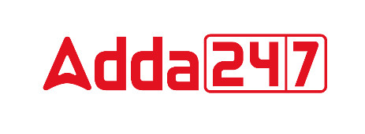

VOCABULARY

1. Altruist (noun)
Meaning; A person showing regard for others

Synonyms: benevolent, humanitarian
Antonyms: selfish, cruel

2. Incongruous (adjective)
Meaning; Not similar or congruent; not matching

Synonyms: incoherent, contradictory
Antonyms: compatible, consistent

3. Embrace (verb)
Meaning; To accept; to undergo; to submit to.

Synonyms: adopt, accept
Antonyms: exclude, reject

4. Obstreperous (adjective)
Meaning; Stubbornly defiant

Synonyms: blusterous, boisterous
Antonyms: silent, compliant

5. Exegesis (noun)
Meaning; An exposition or explanation of a text
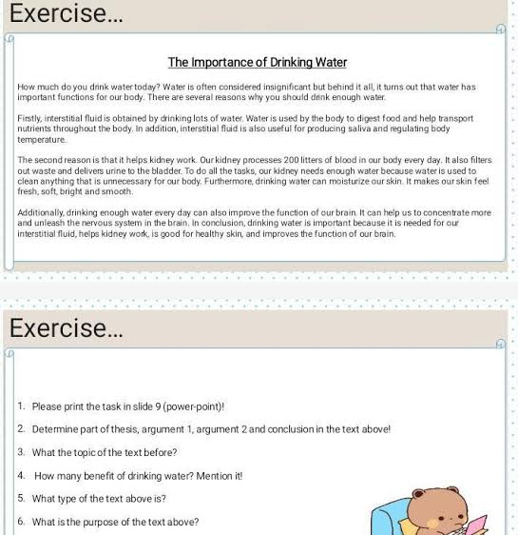
Synonyms: elucidation, illustration
Antonyms: straight, brief

6. Scalding (adjective)
Meaning; An instance of scalding: a burn.

Synonyms: blazing
Antonyms: cold

7. Buttress (verb)
Meaning; Anything that supports or strengthens.

Synonyms: reinforce, strenghten
Antonyms: weaken, reduce

