Patna High Court Assistant Prelims 2023: Exam Analysis
Patna High Court of Judicature has successfully conducted the Patna High Court Assistant prelims exam on 30th April 2023 in a single shift from 12:00 Noon to 02:00 PM at various examination centres situated at Begusarai, Bhojpur at Ara, Gaya, Jehanabad, Muzaffarpur, Patna, and Vaishali at Hajipur. The level of the Patna High Court Assistant Prelims Exam 2023 seems to be Easy to Moderate. The Candidates were very excited after leaving the exam venue to check the Patna High Court Assistant Prelims Exam Analysis 2023 to check their performance in the Patna High Court Assistant Prelims Exam 2023. So, in this article, we will provide the number of good attempts, section-wise difficulty level, and the number of questions asked from different topics in all the given sections.
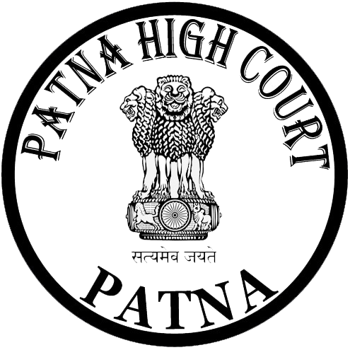

CLICK HERE TO WATCH THE PHC ASSISTANT PRELIMS EXAM ANALYSIS
CLICK HERE TO DOWNLOAD THE PHC ASSISTANT PRELIMS EXAM QUESTION PAPER

Patna High Court Assistant Prelims Exam 2023: Difficulty Level
The PHC Assistant Prelims Exam 2023 is over now and we have come up with the PHC Assistant Prelims Exam Analysis 2023 to check the candidate’s performance in the Prelims Exam and get them self-evaluated through given analysis prepared by our industry experts. Our team of experts from Bihar Adda247 has conducted a thorough analysis of the exam based on the feedback provided by the candidates who took the test. In the below table, we will discuss the difficulty level of the exam and give a deep analysis of the Patna High Court Assistant Prelims Exam 2023. All candidates can check the difficulty level of the Patna High Court Assistant Prelims Exam 2023 provided below.
Sections | Difficulty Level
General Awareness | Moderate
Reasoning & Quantitative Aptitude | Easy to Moderate
General English | Moderate to Difficult
General Hindi | Moderate
Computer Awareness | Easy
Overall | Easy to Moderate

Patna High Court Assistant Prelims Exam Analysis 2023: Good Attempts
- As there were no negative markings so most of the candidates attempted all 100 Questions.

Patna High Court Assistant Prelims 2023: Exam Pattern
Stage | Subject | Maximum Marks | Minimum Qualifying Marks | Duration
Preliminary Test (Objective Type) | General Awareness | 25 | - | -
 | Reasoning and Quantitative Aptitude | 25 | - | -
 | General English | 25 | - | -
 | General Hindi | 15 | - | -
 | Computer Awareness | 10 | - | -
 | Total | 100 | 40 | 2 Hours

Patna High Court Assistant Examination Analysis 2023: Questions Asked
Here we have shared the subject-wise questions and topics which were asked in the Patna High Court Assistant Exam conducted on 30th April 2023.

Subjects | Questions and Topics Asked
General Awareness & Current Affairs | - Amrit Bazaar Patrika  - Longest Day in Australia  - GMT  - Partition of Bengal  - CAG  - Union Territories  - Constitution of India  - Economic Growth is normally coupled with?  - Chairperson of the National Commission for Women at present  - India’s largest trading partner  - CEO of NITI Aayog  - Einstein got his Nobel Prize for?
Reasoning & Quantitative Aptitude | Quantitative Aptitude  - Divisibility rule of 8  - LCM & HCF  - Fraction  - Ratio & Proportion  - Percentage  - Average  - Time & Work  Reasoning  Blood Relation  Number Series  Problem Figures
General English | - Word Meanings- Double Entendre, Circumlocution, Contretemps, Catharsis, Relinquish, etc.  - Idioms/Proverbs - To read between the lines, On the spur of the moment  - Error Detection  - Fill in the blanks  - Passage
General Hindi | - अपठित गद्यांश  - शब्दार्थ - जिजीविषा, डींग हांकना  - मुहावरे  - पर्यायवाची शब्द - दामिनी, मरकट,  - विलोम शब्द - गरिमा  - उपसर्ग प्रत्यय  - समास
Computer Awareness | - Second Generation Computer  - Father of Super Computing  - Brain of the Computer  - CAD stands for?  - Operating System

